**Endpoint PCR and Gel Protocol**

**Updated 3/4/24**

The following reaction mixture is suggested for purposes such as cytochrome b amplification and tissue testing of environmental primers. Variations may be made based on particular situations. Remember that environmental samples cannot be run with GoTaq unless inhibitors are removed, or the environmental master mix is used.

Remember that the GoTaq aliquots in the -20 must be centrifuged to knock down the ice, thawed, and then vortexed for a minute or more until homogenous. Failure to do so will prevent the reaction from running.

|  |  |
| --- | --- |
| **Ingredient** | **Volume** |
| GoTaq Green 2X Master mix | 12.5 μl |
| Template DNA | 2 μl |
| Forward Primer (2 μM) | 1 μl |
| Reverse Primer (2 μM) | 1 μl |
| Nuclease free water | 8.5 μl |
|  |  |
| Total Volume | 25.0 μl |

* The recommended PCR protocol for GoTaq is listed below. The annealing temperature should in general be 5 degrees lower than the TM of the primer although optimization of this is ideal when using a new primer.

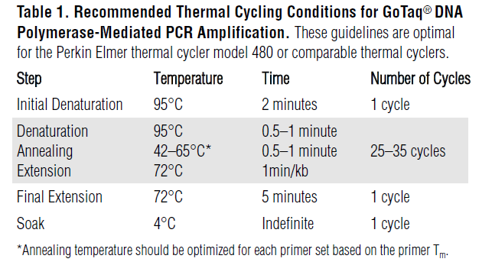

* The program will take several hours and hold at 4 oC when complete although it is best (for the machine) to not leave longer than overnight in this state. Remove the samples and store at 4 oC if examining them within 48 hours, -20 oC if longer.

**Pouring a gel**

* Measure 30 ml of deionized water (from our system is fine) in a graduated cylinder and add 0.6 ml of Edvotek running TAE running buffer 50X concentrate.
* Pour this into 50 ml beaker and add 0.3 grams agarose .
* Heat this in the microwave until completely dissolved (no powder is visible), usually takes 20-30 seconds. Too long and it will bubble out of the beaker.
* Add 3 ul of gel red to the still hot agarose.
* Gently swirl to assure thorough mixing.
* Pour still completely melted contents into gel mold (use the larger comb spacers).
* Allow to harder 30 minutes or more before removing comb and end stops.

**Running the gel**

* Place gel in running box filled with running buffer. Running buffer can be left in the box for weeks or months if the lid remains on. New buffer is made as described in step #1 of puring a gel. Be sure the wells are on the negative side of the gel box so the negatively charged DNA moves toward the positive charge on the opposite side.

Note – The gel may either be left in the mold (with the end stops removed) or taken out. If you have more than two gels to run you will have to remove it since we have only two molds.

* Load 10 of the PCR reaction into each well, be careful to label which samples is in which well.
* **Load only 3 ul of the DNA ladder**.
* Replace the lid and turn on the gel box. Set the voltage to 90 V, hit the run button.
* The gel will need to run for 45 minutes to an hour, until the visible dyes are 75-80% of the way across the gel.
* Place the gel on the viewing box view under UV light.

Hyper 25 BP ladder

